**Video Middleware**

**MyTVs Application   
User Guide**

# 

The information presented in this document is written for the default settings of the system. The *MyTVs Application User Guide* may be reformatted to fit your company needs. All screen captures used in this guide are available as individual .png or .jpg images.

This guide is a working document. The information and screen captures represented in this document may change frequently and without notice.

# MyTVs Application

1. Download the MyTVs application from the appropriate user store (Apple App Store or Google Play Store).
2. Select the MyTVs icon from the screen. Click ADD NEW ACCOUNT.
3. Follow the steps in the App to link your device to your Video Account through your STB.
4. Select Menu on your TV remote control.
5. Arrow down to Settings-Apps-Device Code.
6. In the Manage Your Devices screen, Your Device Code will appear in the window.
7. Enter the Device Code into your MyTVs app.
8. Click PAIR DEVICE.
9. Enter the 8-digit Passphrase into your MyTVs app from the Manage Your Devices window on your TV.
10. Click PAIR DEVICE and enter an Account Name.

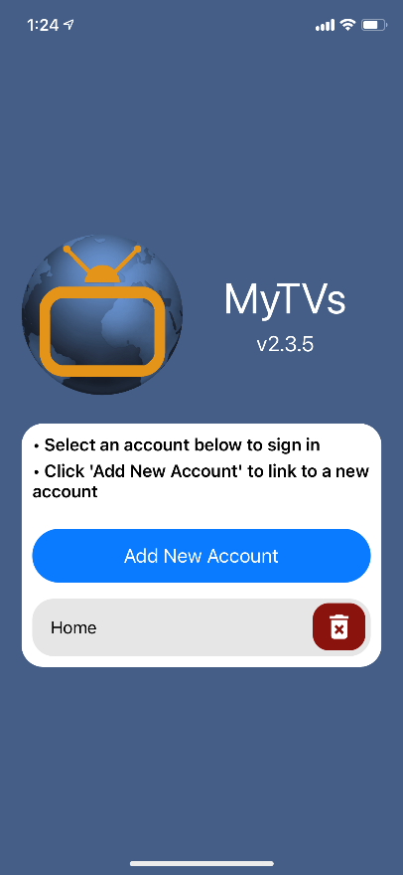

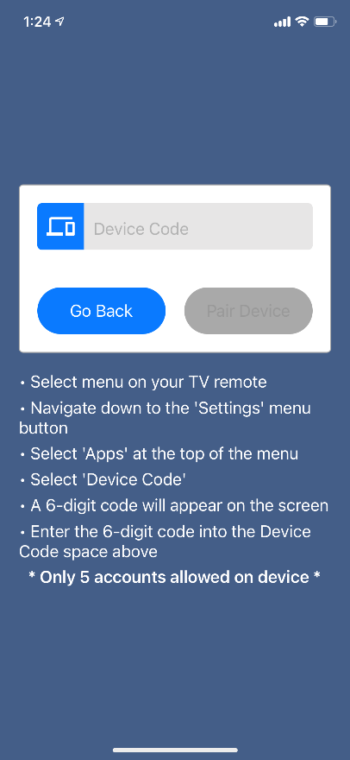

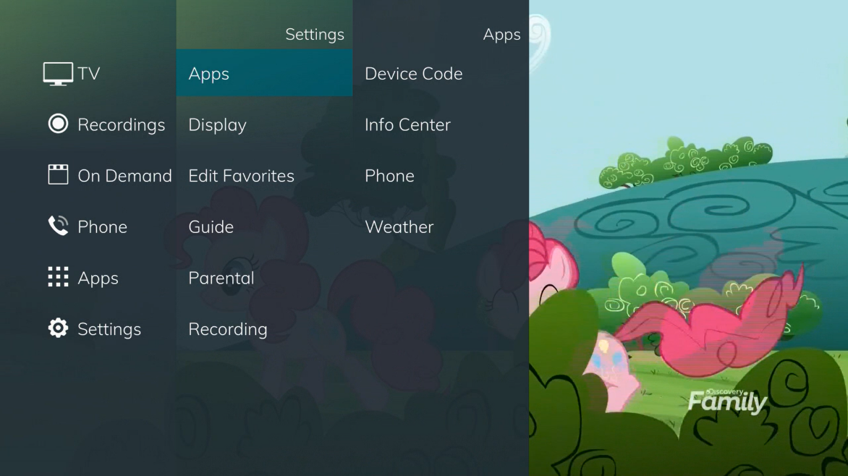

**Pair Device**

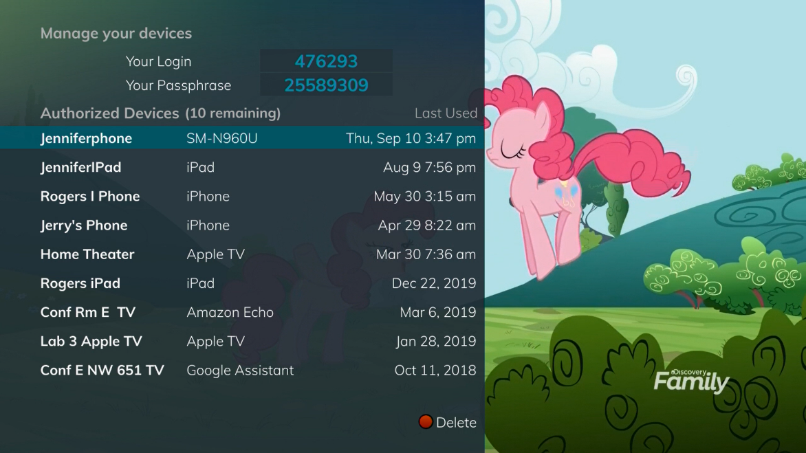

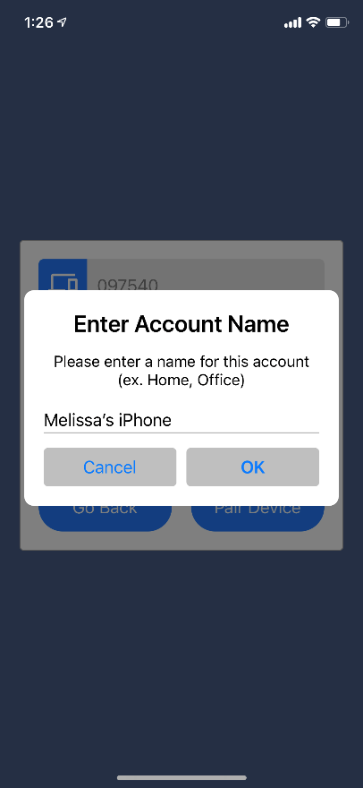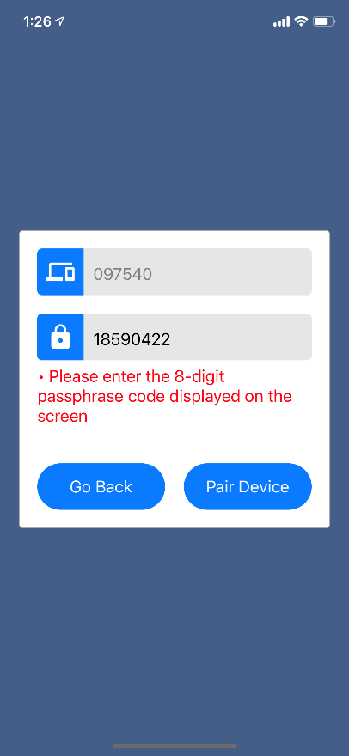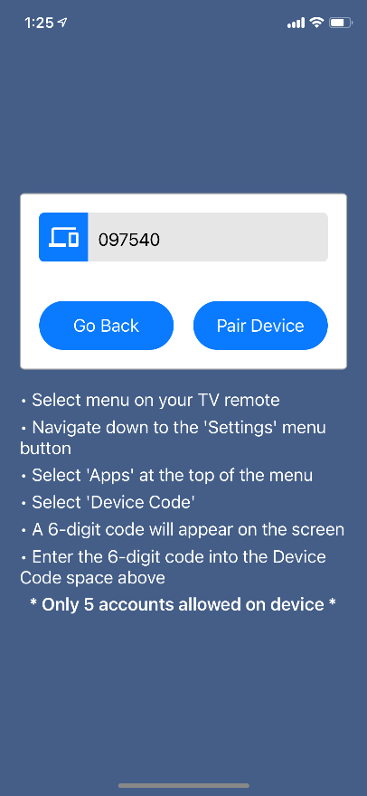

### MyTVs Menu

The following sections provide details for accessing the program guide, searching for a specific program, showing existing recordings or scheduled recordings, and using your smartphone as a working remote control with your set top box:

* **Remote**

This action allows you to use your smartphone as a functional remote control.

* **For You**

For You provides the user with real time information about the most popular watched programs in the user’s area as well as the most popular recordings and movies.

* **Guide**

The Guide allows the user to view guide information by time and date. Programs may be selected within from the guide to view program details, schedule future recordings, and watch program.

**Figure 1-2 MyTVs Menu**

* **Channel Guide**

The Channel Guide allows the user to view guide information by channel. Program may be selected within the guide to view program details, schedule recordings, and watch program.

* **Currently Watching**

Shows the user what is currently being watched on the selected STB.

* **Recordings**

All existing and scheduled recordings may be viewed within the Recordings menu. Users may select a STB from within their home and view either Current, Future and Series recordings. Allows the management of recordings to include deleting recordings or series.

* **On Demand**

On Demand will take users to the On Demand library.

* **Search**

This action allows the user to search by titles, programs, keywords, or phrase for a specific program. Search results may be selected to view program details and schedule future recordings.

* **Settings**

Users can mange their account, switch accounts, add devices, and refresh user and guide data.

# Remote Control

This action allows your smartphone to function as a remote control. If the user swipes to the left, a number pad will appear and the user may enter a specific channel number to tune to, or channel up or down to change channels.

# 

# For You

1. To view For You, select For You from the MyTVs Menu.
2. For You will show the most watched TV programs, Recordings, and Movies.
3. To view the program information, select a program and a Program Details window will appear with the program description, the air date and time, and the channel number the program will be aired on.
4. From this Program Details window, users can also Search for more air times of this program, set a recording of this program, or watch.

# 

# Guide

1. To view the guide data by time, select Guide from the MyTVs Menu at the top left corner of the app screen. If a user would like to view the program guide data by channel, they should select Channel Guide from the MyTVs Menu.
2. Begin browsing the Program Guide by swiping left or down for other shows in same time slot, right for next timeframe, or use channel numbers on right side.

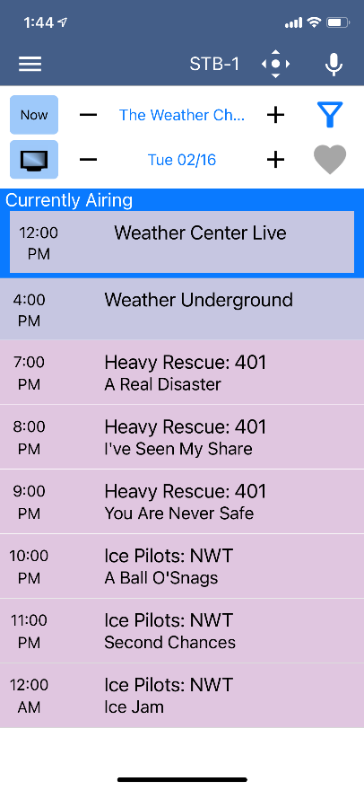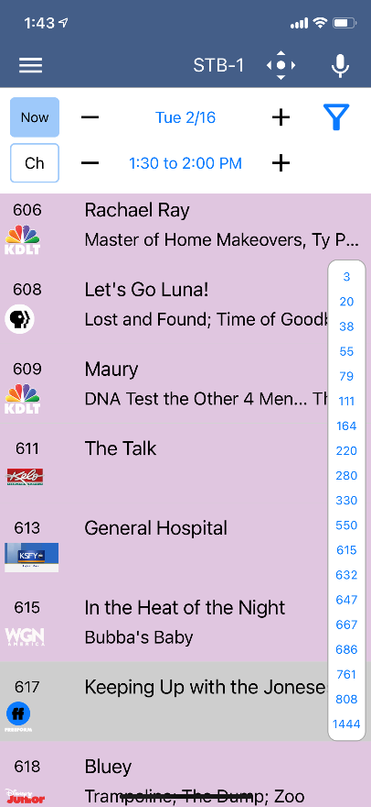

1. 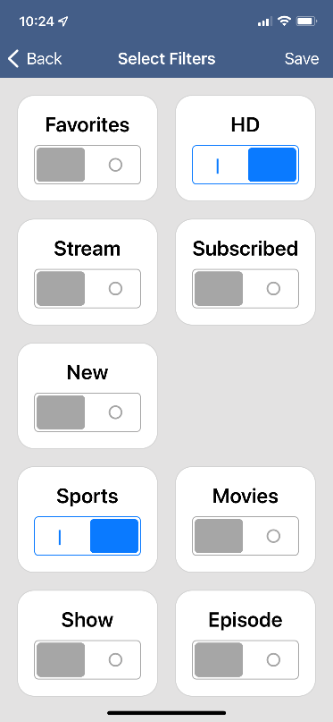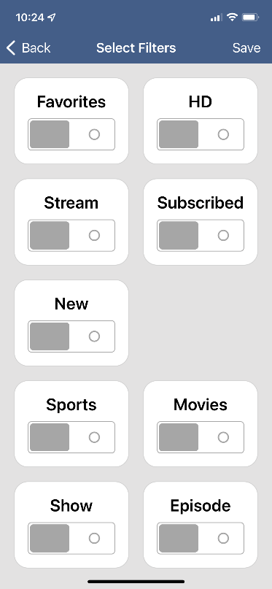To filter the program guide, click the Filter Funnel icon. Click on any filters to have them applied to the program guide content and click “Save”.

**Currently Watching**

To see what is currently playing, select the Currently Watching from the MyTVs app menu.

1. Search uses the universal search feature to look for more show times, recordings, or VOD events.
2. Record allows the user to set a recording or series recording.
3. The Eye icon allows for HLS viewing of that show on a device. NOTE: Must have HLS signal on that particular channel.

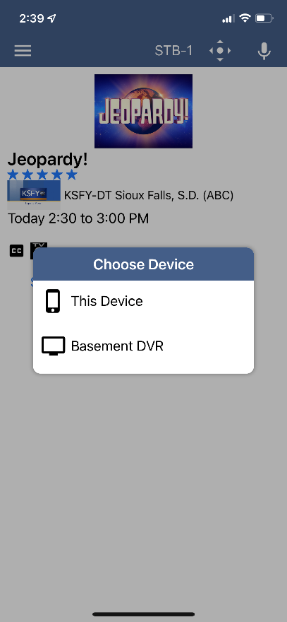

# Recordings

1. To show existing recordings, scheduled future recordings, and series recordings, select the Recordings button from the MyTVs menu.
2. To view existing recordings, select the Recorded option at the top of the screen. To view future scheduled recordings, select the Future option. To view Series recordings, select the Series option.
3. You also have options at the top of the screen to customize how your recordings are listed – Alphabetical or By Date. You can also show the recordings Grouped or not grouped. And you can choose which Folder you would like to view recordings from.

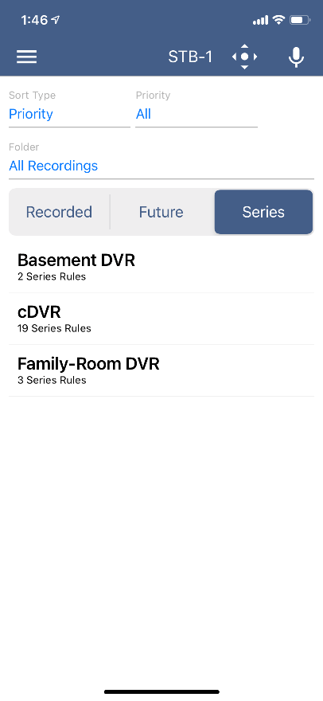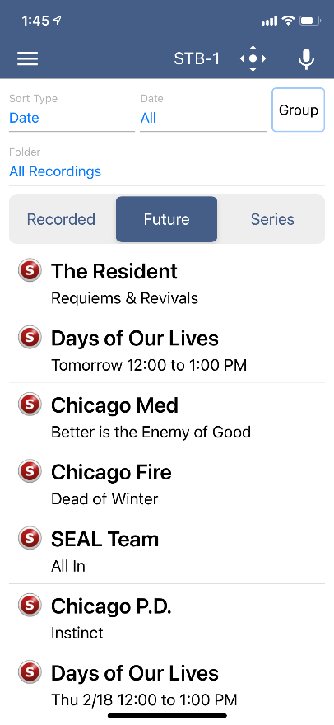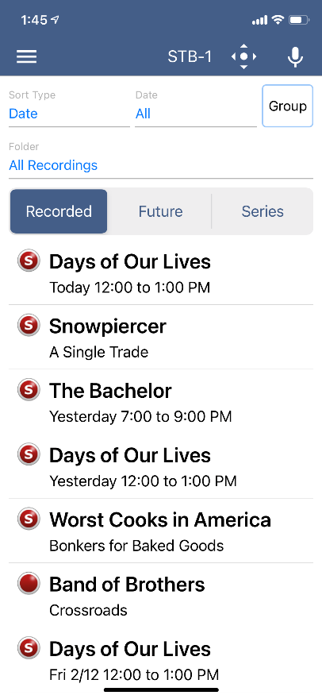

1. When you select a recording, a Program Details window will appear with the program description, the air date and time, and the channel number the program will be aired on. To delete the existing recording or a future scheduled recording, click on the blue *Edit* which will bring up an Edit Recording screen. This screen will give you program details and allows the user to edit the Folder this recording will be in and if this should be a protected recording. Click *Delete Recording* on the bottom of the screen to delete or *Save Changes* if any changes were made.

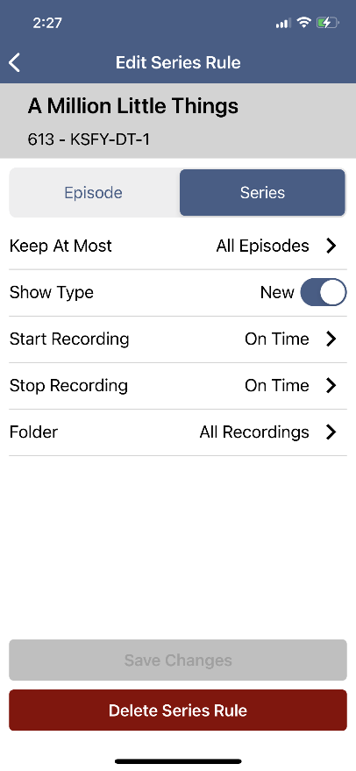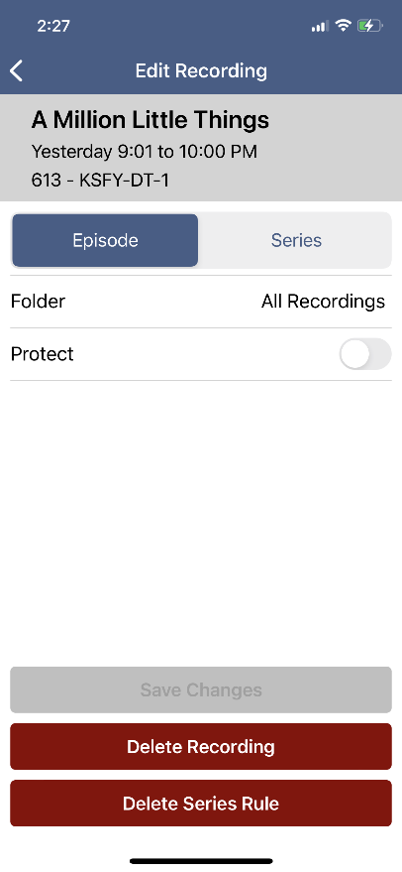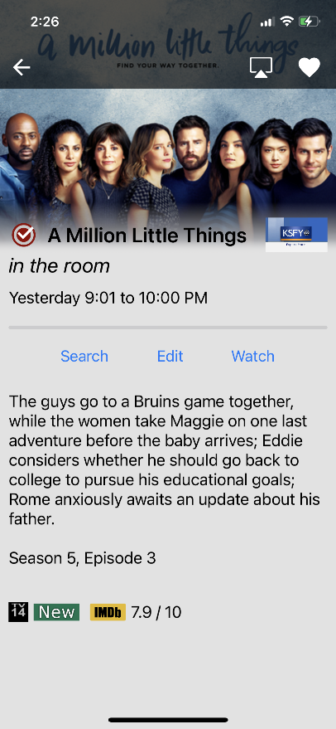

1. When you select a Series Rules, an Edit Series Rule page appears. This screen allows you to edit the number of episodes saved, Show Type, Start Time, Stop Time, and Folder where the recordings are saved. Click *Delete Series Rule* to delete or *Save Changes* if any changes were made.

**On Demand**

To access the On Demand library, select On Demand from the MyTVs menu. The On Demand library has multiple library categories: Just In, Ending Soon, Movies, and TV Shows. Click on a sub-library for a list of on-demand programs available in that category.

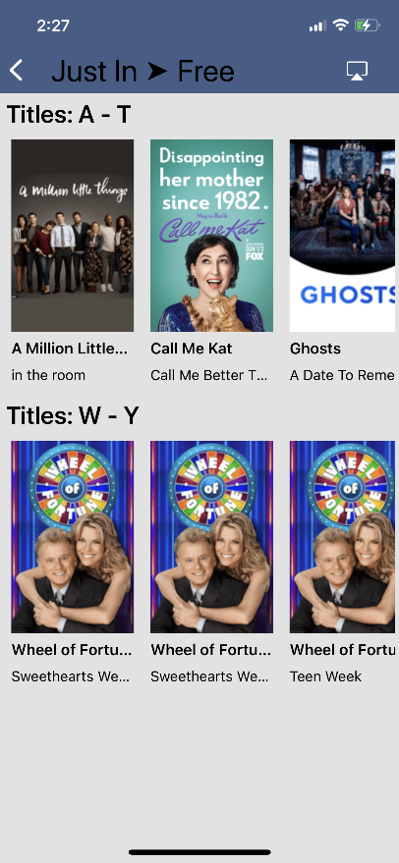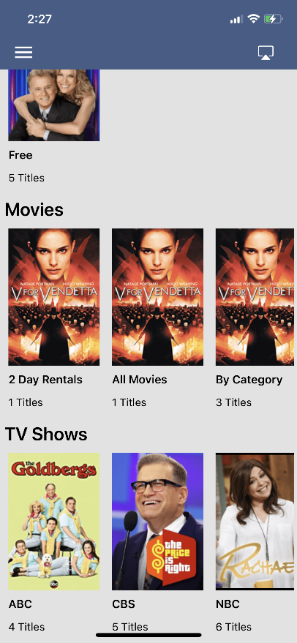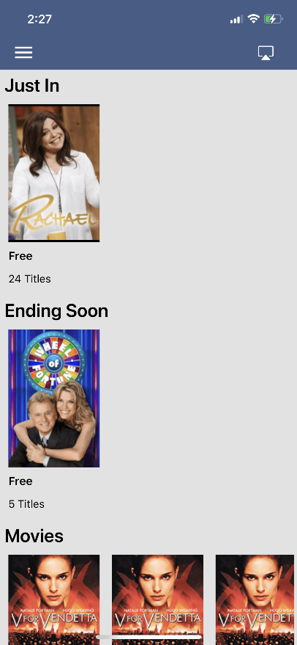

**Program Search**

To search for a specific program, select Search from the MyTVs menu.

1. Enter the desired phrase or keywords into the Search Text field. Click on the search icon.
2. Results for the search will appear below the Search Text field. Search results are available from Guide, Recordings, and VOD. By clicking on the different buttons under the search text field, a user will see results for the Program Search from each different section.

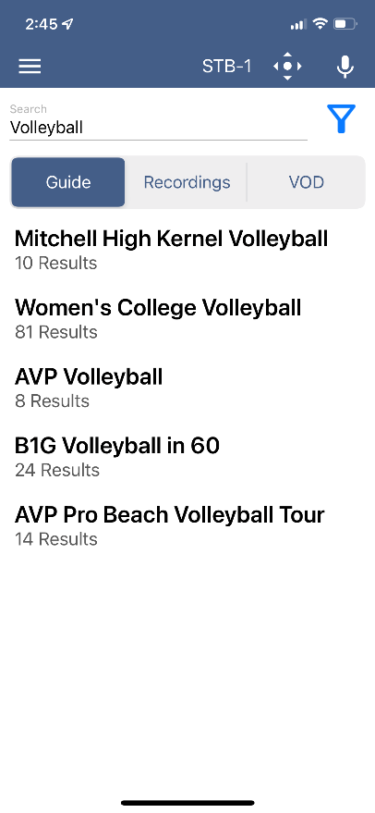

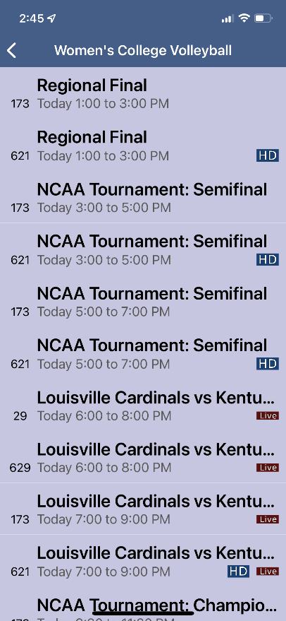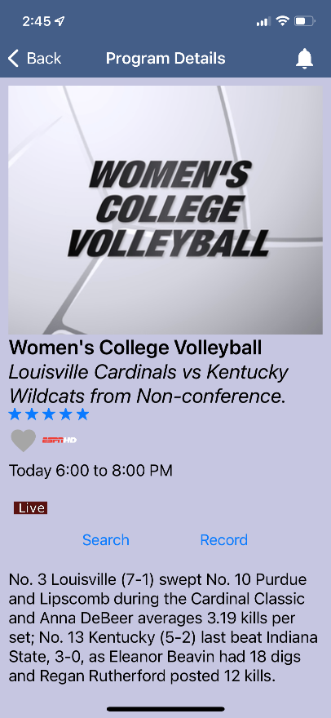

1. From the search results, a user can select the program (episode) they would like to view, and a Program Details screen will appear with the program description, the air date and time, and the channel number the program will be aired.
2. In the Program Details window, click Search to view future programming or click Record to set a recording of this program.
3. If your provider offers Restart TV, you will have the ability to record the show or event from the beginning.

**Settings**

Click on Settings in the MyTVs menu to view Account information.

1. A user can manage their account by clicking on Account Name.
2. They can also switch to a different account or add another device by clicking on Accounts.
3. Users can manage their devices synced to their MyTVs app by choosing Manage Devices.
4. Refresh All Data allows all settings, recordings, and guide data to be refreshed and updated.

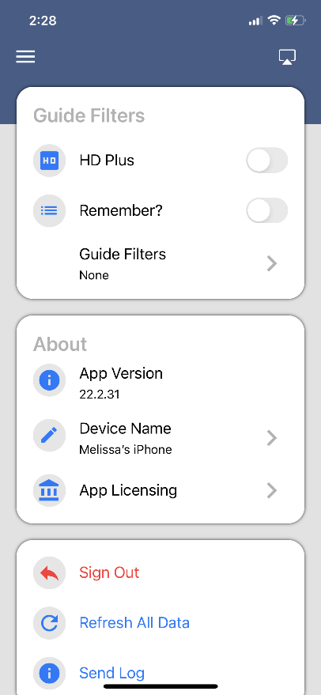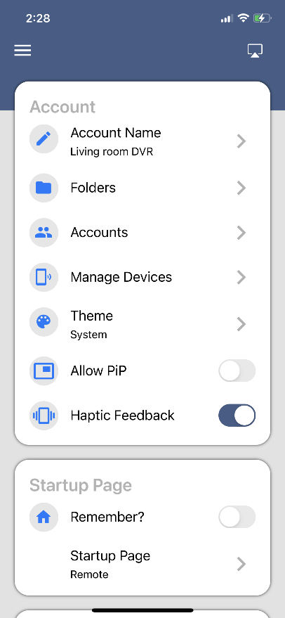

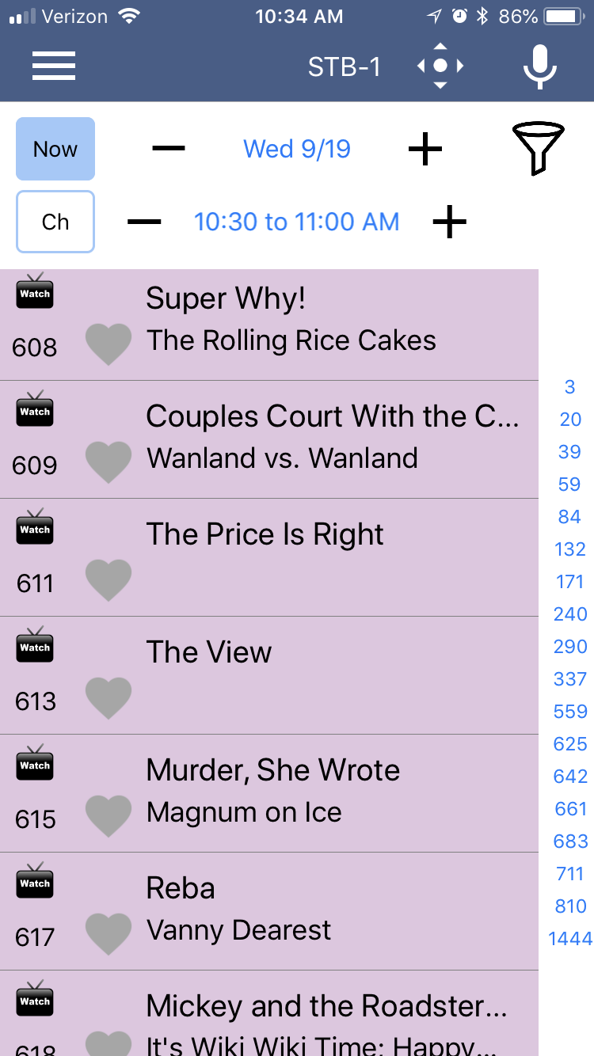**Voice Commands**

To activate the Voice Commands functionality,

1. Click on the microphone icon at the top right-hand corner of the MyTVs app.
2. This will bring up a Voice Commands screen and show a list of available commands – App Commands, Remote Commands, and Extended Remote Commands.
3. Click on the Microphone button and speak the command.

NOTE: You must have Microphone and Speech Recognition activated on your smartphone in the MyTVs App settings.

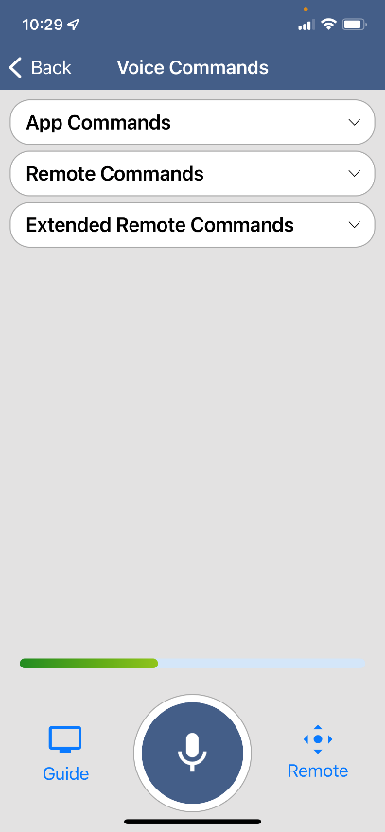

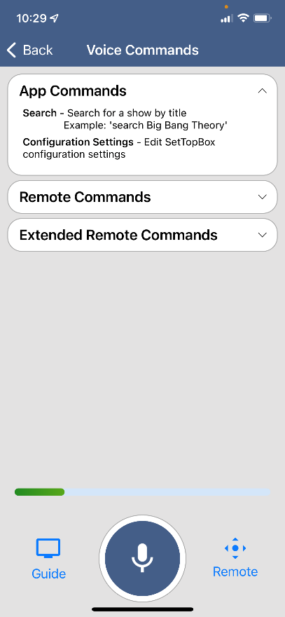

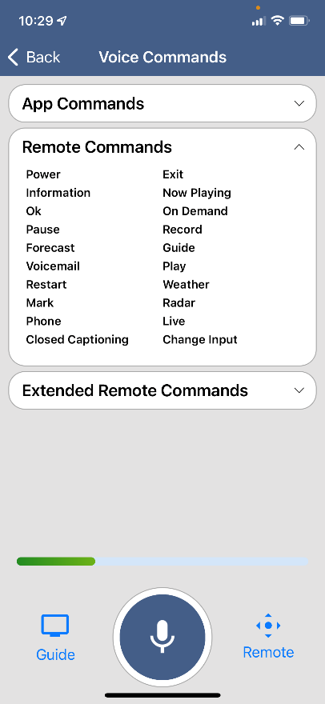

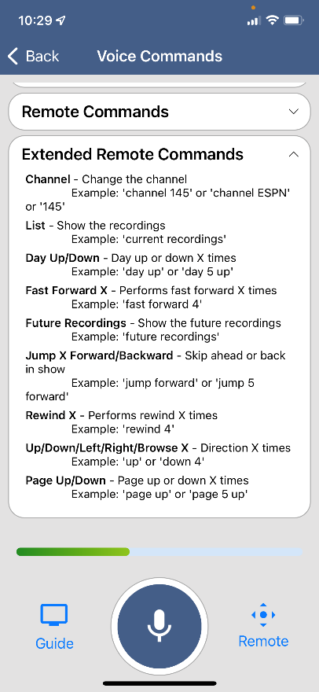

**Audio Accessibility**

Accessibility mode is not a MyTVs App setting. It is a device setting and called “Voice Over” on Apple Devices (<https://www.apple.com/accessibility/iphone/vision/>) or “Talk Back” on Android devices (<https://support.google.com/accessibility/android/answer/6283677?hl=en>).  This mode will not just apply to the MyTVs app.  Once enabled and in the accessibility mode, the device will talk back about what is happening on the device.